# Book Library System.

Created By – Akshada Patil

Local URL - <http://localhost/bookLibrary/CodeIgniter-3.1.9/>

**Basic View :**

* The User will be able to see only the list of books available in the library.
* In order to borrow or check it’s availability, the user needs to sign up.

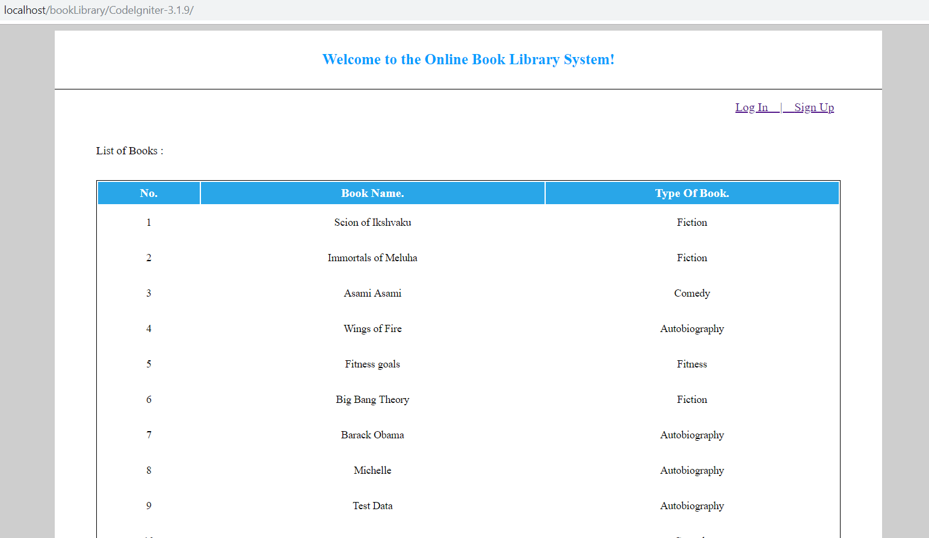

Fig 1. Basic View

**Sign Up :**

* The user needs to create a username and password and thus becomes a member.

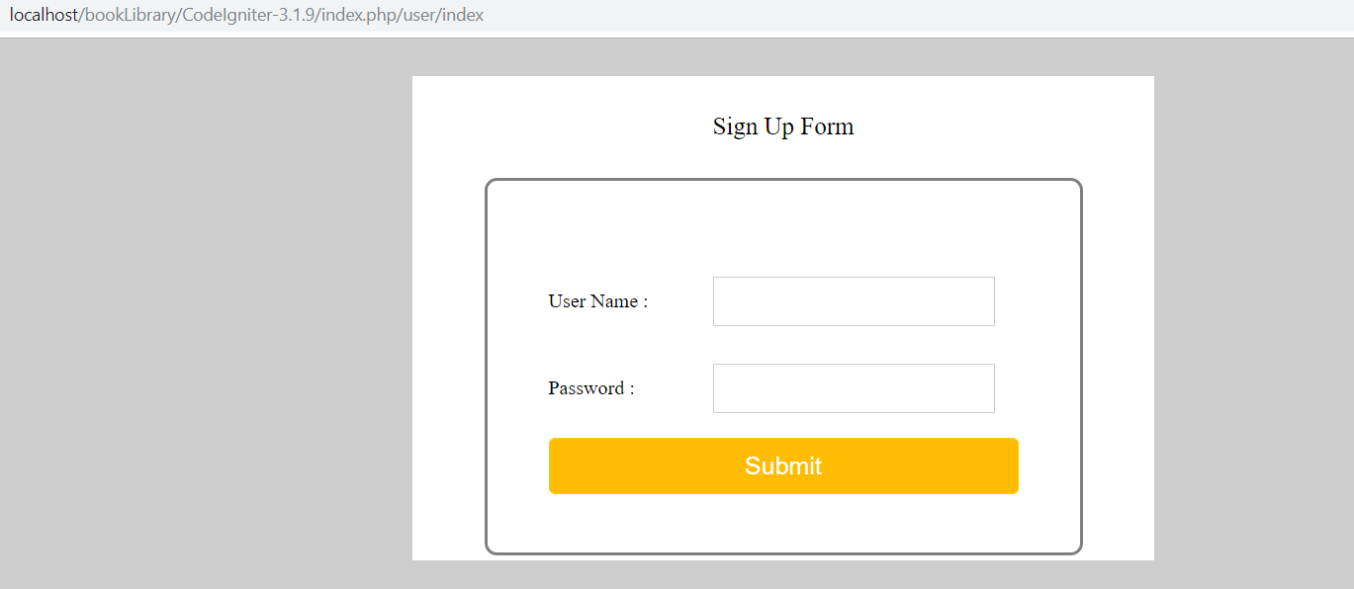

Fig2. Sign up Form

**Log In :**

* The user can log in using his credentials and the various options are now available.
* User can check the availability of the book.
* User can Borrow a book.
* User can return a book, if borrowed.

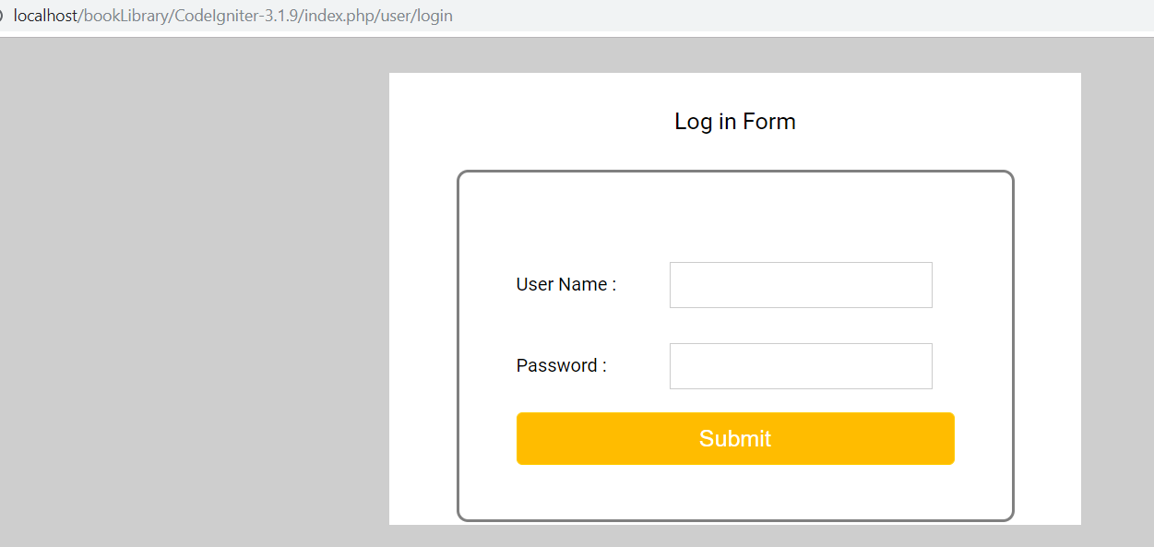

Fig 3.1. Log in Form

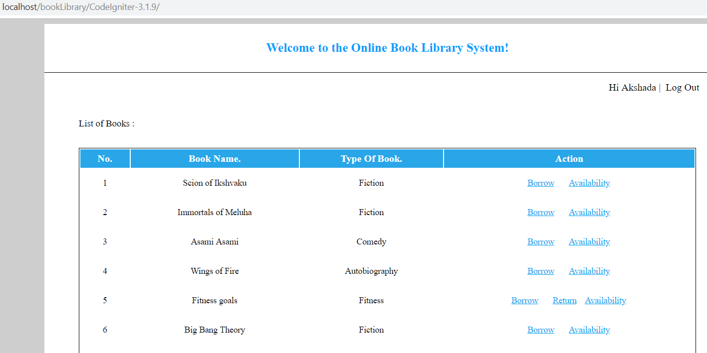

Fig 3.2 Signed In User View

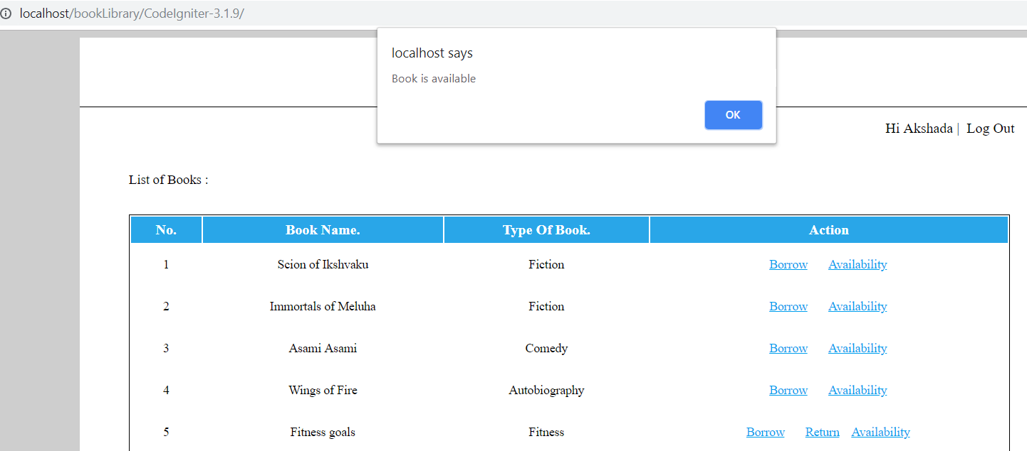

Fig 3.3 Check if Book Is Available

**Admin**

* An admin with credential username=”admin” and password=”admin” can log-in.
* The admin can Add a Book to the library.

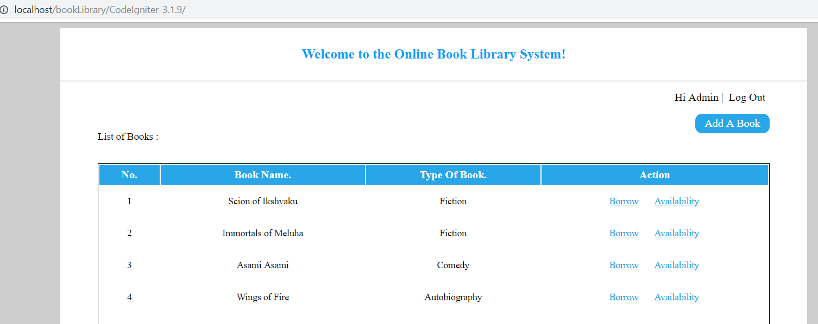

Fig 4. Admin View

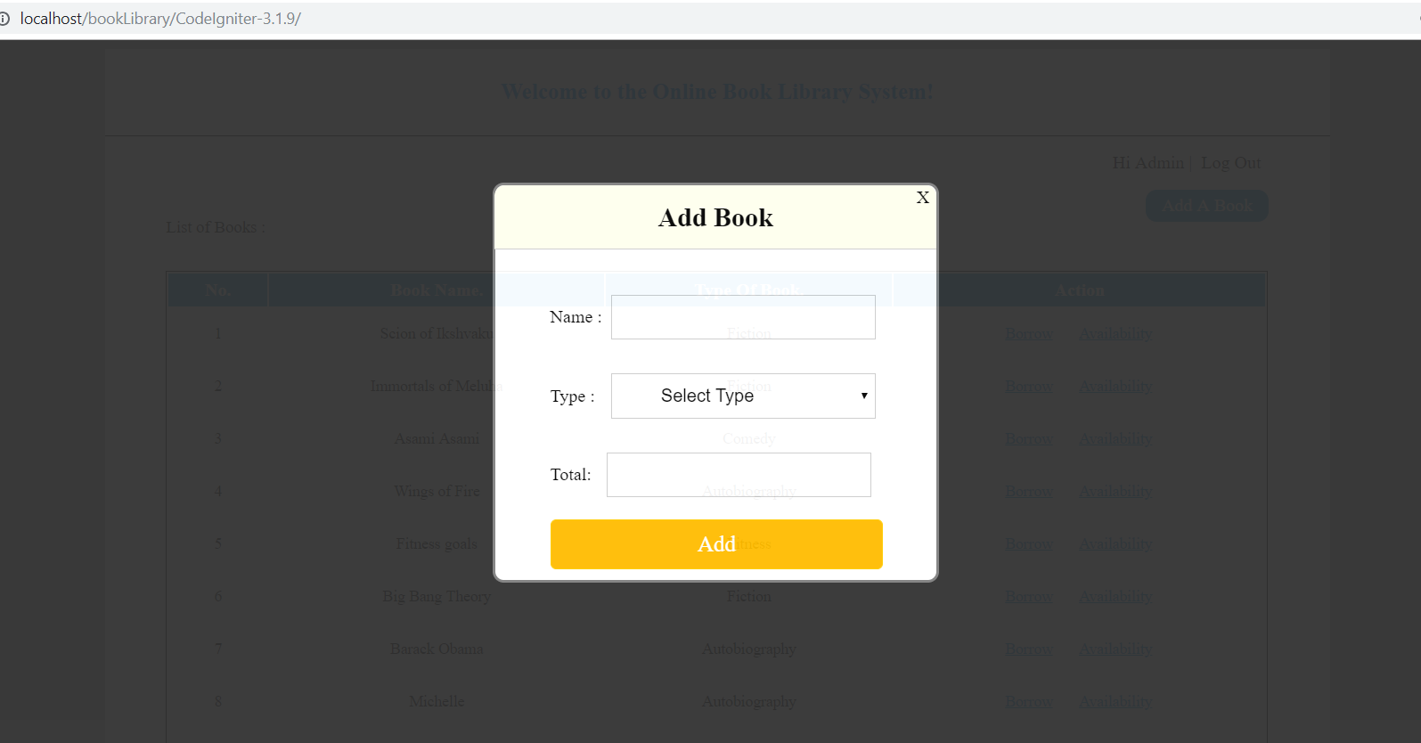

Fig 4.1 Add Book